Name:
Course ID-Section: IT228-G__
Laboratory Activity 5

Laboratory Activity 5A
Using Traceroute to Discover the Network
b. What address did the command return for b2server? 128.107.64.254
e. What is different about the traceroute command on the router compared to tracert on the PC?
one less hop since the command is originating from R4, the order of the fields in the output is different listing the IP address in the first column.
What is the significance of R4 to Sales? It is the default gateway for Sales
f. Based on the output of the command, which interface is used to reach the next device in the list output from the tracert command?Interface S0/0/0 is connected to the 64.100.150.0 network.
g. What is the name of the device to which you are connected? Tier3a
i. Based on the show ip route command output, which interface is the exit interface for the next IP address listed in your original tracert output? GigabitEthernet0/0
j. What is the hostname of the current device? ISP-Tier3b
What networks are connected directly to this router? Answer here
Which interfaces connect the devices between trace route 2 and trace route 3? Answer here
k. What is the name of the device? Answer here

Addressing Scheme Table Documentation
Trace Route ID | Device | Interface | Address | Subnet Mask
- | Sales | NIC | 172.16.0.x (DHCP) | 255.255.255.0
1 | R4 | G0/0 | 172.16.0.0 | 255.255.255.0
 |  | S0/0/0 | 64.100.150.1 | 255.255.255.252
 |  | S0/0/1.1 | 64.100.200.1 | 255.255.255.252
2 | ISP-Tier3a | G/0 | 64.104.22.1 | 255.255.255.252
 |  | G0/1 | 64.104.223.1 | 255.255.255.252
 |  | S0/0/0 | 64.100.100.2 | 255.255.255.252
 |  | S0/1/0 | 64.100.150.2 | 255.255.255.252
3 | ISP-Tier3b | G0/1 | 64.104.222.2 | 255.255.255.252
 |  | G0/2 | 64.100.8.1 | 255.255.255.0
 |  | F0/1 | 128.107.46.1 | 255.255.255.0
 |  | F/0/2 | 64.104.222.5 | 255.255.255.252
4 | B2-R1 | G0/0 | 64.104..222.6 | 255.255.255.252
 |  | G0/1 | 128.107.64.1 | 255.255.255.0
5 | b2server.pt.pka | NIC | 128.107.64.254 | 255.255.255.0

Topology Documentation
Attach a hand-drawn topology of the new branch location. Include your name, course code and section, as well as the date of completion.
Screenshot of Check Results (with the congratulatory message that includes your name on a red box):
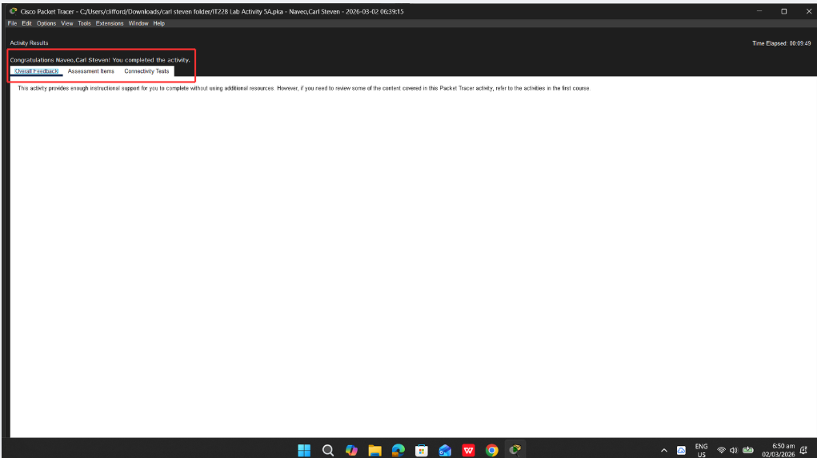

Laboratory Activity 5B
Configuring and Verifying a Small Network
Part 2: Gather Information with Show Commands
Step 1:
- Which commands display the status of the port? Show ip interfaces brief, show interfaces, show ip interfaces
- Which command shows only the IP address (no subnet mask or prefix)? Show ip interface brief
- Which command displays the description configured on the interface? Show interfaces
- Which command displays the IP broadcast address? Show interfaces
- Which command displays the MAC address of the interface? Show interfaces
Step 2:
- How many networks are known by the router based on the output of the show ip route command? 2 – 10.10.10.0/24 & 10.10.20.0/24
- What does the L at the beginning of the lines within the routing table represent? Local Connection
- What does the /32 prefix listed in the route table indicate? The Host address of the interface
Step 3:
- On RTA, shut down the Gigabit Ethernet 0/0 interface and issue the show ip route command. How many networks are displayed in the routing table now? 1 – 0.10.20.0/24
- Attempt to ping PC1. Was the ping successful? No
- Issue the show ip interface brief command. What is the status of the Gigabit Ethernet 0/0 interface? Administratively Down
- Reactivate the Gigabit Ethernet 0/0 interface. Issue the show ip route command. Did the routing table repopulate? Yes
What can be inferred about the interface status of routes that appear in the routing table? Interfaces must be active in order to be listed in the routing address
Screenshot of Assessment Items (with name and score on a red box):
